Date | 27 June 2026
Team ID
Project Name | Network Request Management System
Maximum Marks
Project Development Phase

1. Introduction
The Automated Network Request Management System was developed as a scoped application on the ServiceNow platform. The objective of this implementation phase was to automate the end-to-end lifecycle of network service requests by replacing manual email-based processing with a centralized and workflow-driven solution. The application provides a self-service Service Catalog, automated approval workflows, task assignment, role-based access control, real-time request tracking, and email notifications. This enables faster request fulfilment, improved transparency, and better operational efficiency for IT network teams.
2. Milestone 1 – Service Catalog Setup
Objective
Create the Service Catalog and initialize the network request management system.
Activities Performed
- Created the Network Services catalog and category.
- Developed catalog items for network service requests.
- Configured catalog variables and prepared the development environment.
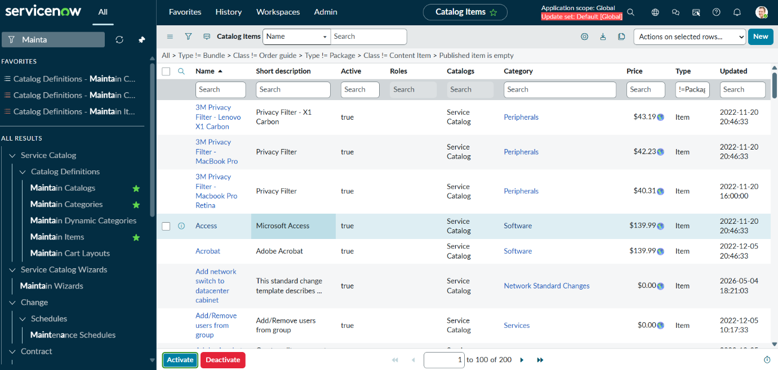

3. Milestone 2 – Database Configuration
Objective
Create the custom database tables for storing network request details and task information.
Activities Performed
- Designed the u_network_database table to store network service requests.
- Created the u_network_task table to manage request fulfillment tasks.
- Added fields such as Request Number, Requested By, Request Type, Department, Priority, Status, Assigned To, Due Date, and Comments.
- Configured reference fields linked to the sys_user table for users and assignees.
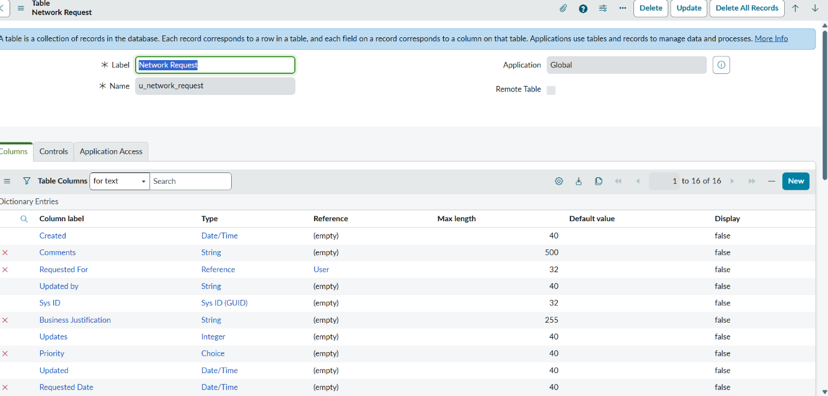

Milestone 3 – User & Role Configuration
Objective
Configure application users, user groups, and role-based access control for the Automated Network Request Management System.
Activities Performed
- Created Employee (Requester) user accounts.
- Created Manager (Approver) user accounts.
- Created Network Engineer user accounts.
- Created System Administrator user accounts.
- Configured Network Operations assignment group. Assigned Employee role to users for submitting network service requests.
- Assigned Manager role for reviewing and approving requests.
- Assigned Network Engineer role for implementing approved network tasks.
- Assigned System Administrator role for managing application configuration, workflows, and user access.
- Verified role-based permissions and access to Service Portal, Service Catalog, custom tables, and workflow components.
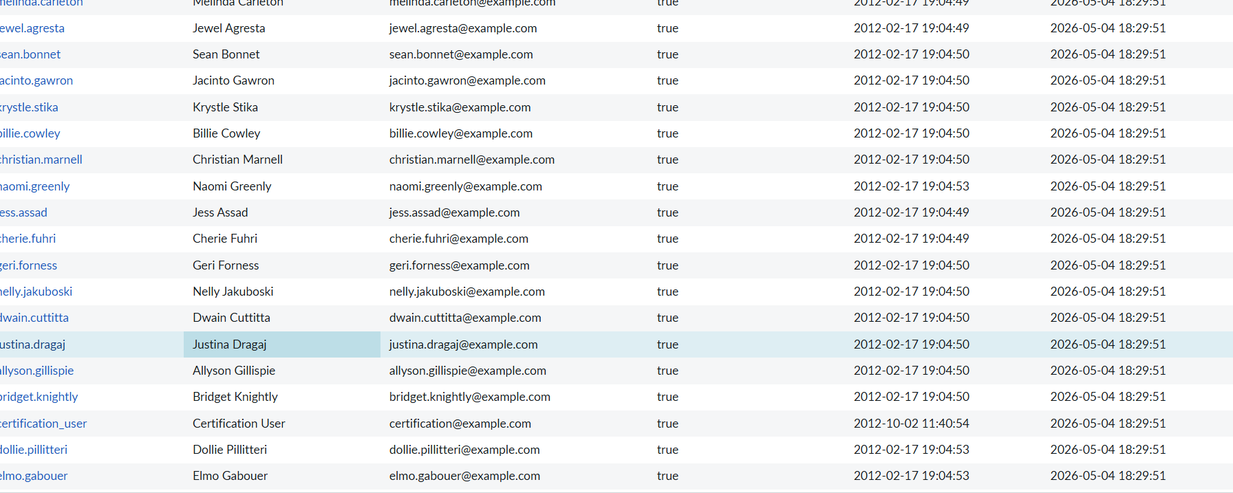
5. Milestone 4 – User Interface Development
Objective
Develop intuitive and user-friendly interfaces for employees, managers, and network engineers to efficiently submit, manage, and track network service requests.
Activities Performed
- Designed the Network Service Request Catalog Item for submitting network requests.
- Configured catalog variables to capture request details such as Request Type, Priority, Business Justification, and Configuration Information.
- Developed user-friendly request forms using the ServiceNow Service Catalog.
- Implemented Catalog UI Policies to provide dynamic form behavior by showing, hiding, and making fields mandatory based on the selected request type.
- Configured Catalog Client Scripts to perform client-side validation and improve user interaction.
- Designed separate interfaces for request submission and request fulfillment based on user roles.
- Customized form layouts to improve usability and simplify data entry.
- Validated the user interface to ensure a consistent and responsive user experience across different request scenarios.
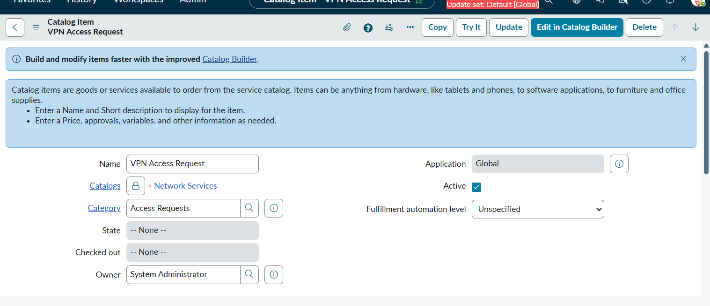
6. Milestone 5 – Workflow Automation
Objective
Automate the complete lifecycle of network service requests, including request processing, approval, task creation, assignment, notifications, and request closure using ServiceNow Flow Designer.
Activities Performed
- Developed an automated workflow using ServiceNow Flow Designer.
- Configured the workflow to trigger automatically when a network service request is submitted.
- Implemented an approval process for requests requiring managerial authorization.
- Automated the creation of implementation tasks for approved network requests.
- Configured assignment rules to automatically assign tasks to the Network Operations team.
- Implemented automated email notifications for request submission, approval, rejection, task assignment, and request completion.
- Configured automatic request status updates throughout the workflow lifecycle.
- Validated the end-to-end workflow to ensure successful automation from request submission to closure.
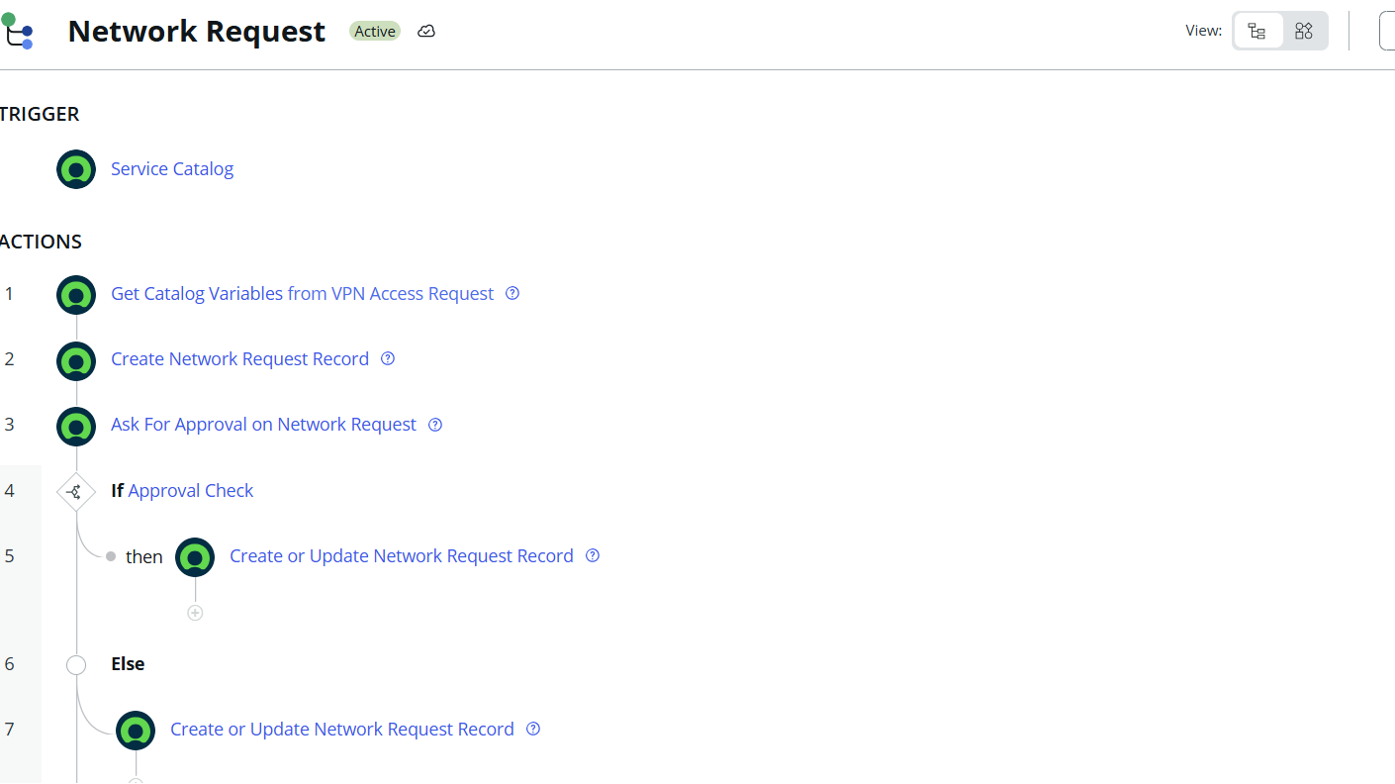

7. Milestone 6 – Application Testing
Objective
Validate the end-to-end functionality of the application.
Test Scenario 1
Student submits a leave request.
Expected Result:
Leave request is created successfully.
Status:
Passed
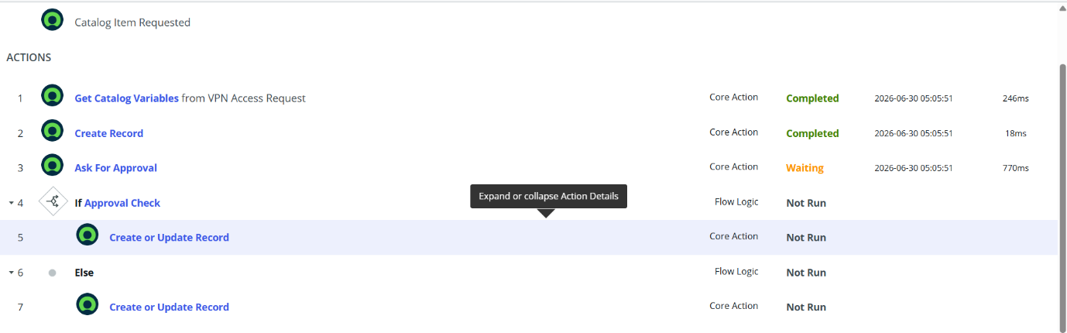

Test Scenario 1 – Request Submission
Objective: Verify that an email is generated when a network request is submitted.
Steps:
- Login as an Employee.
- Open the Service Portal.
- Submit a VPN Access request.
- Click Submit.
Expected Result:
- Request is created successfully.
- Status changes to Pending Approval.
- A submission email notification is generated.
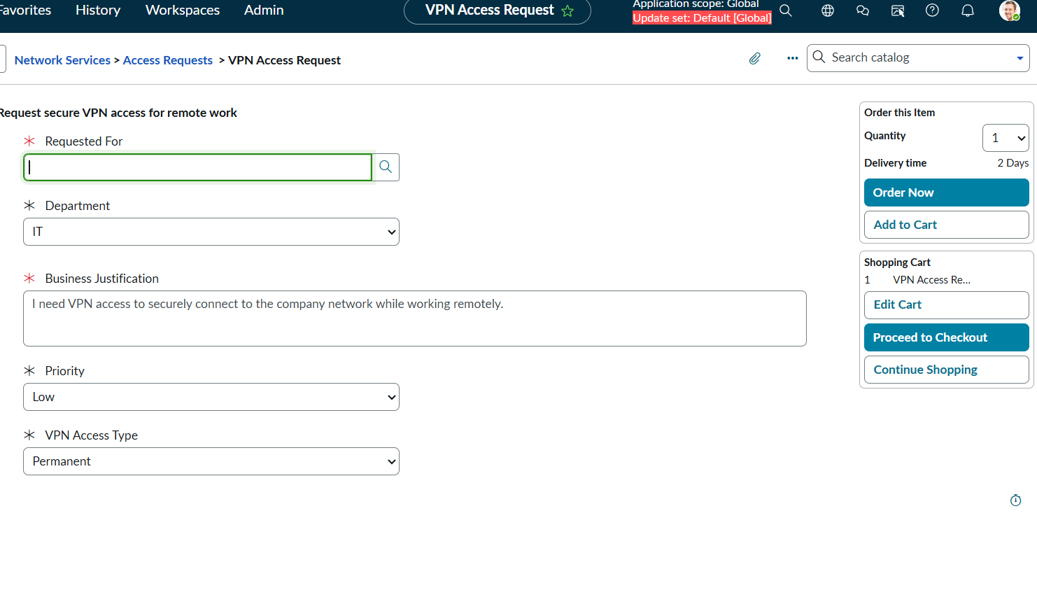
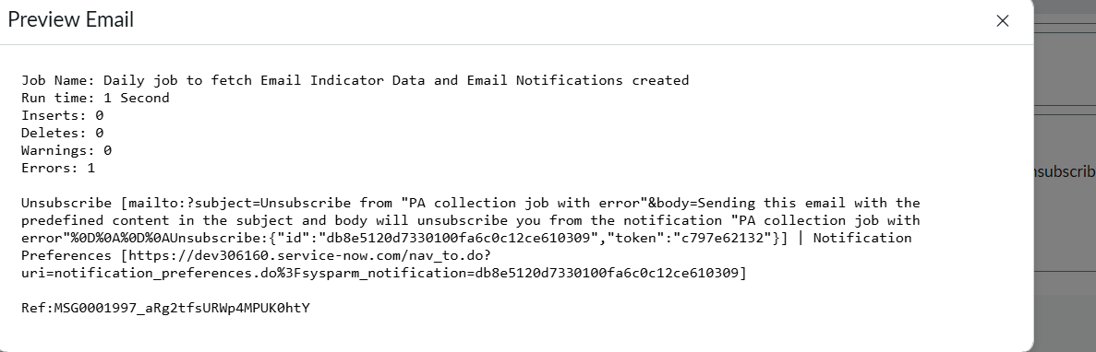
8. Development Summary
The Automated Network Request Management System Using ServiceNow successfully implements a centralized and automated platform for managing network service requests. The application integrates a user-friendly Service Portal, Service Catalog, role-based access control, workflow automation through Flow Designer, approval management, automatic task assignment, and email notifications to streamline the complete request lifecycle. Custom ServiceNow tables are used to securely manage network request records and implementation tasks, while reports and dashboards provide real-time visibility into request status and system performance. All major functional requirements were successfully implemented, tested, and validated to ensure efficient, reliable, and transparent network request management.

